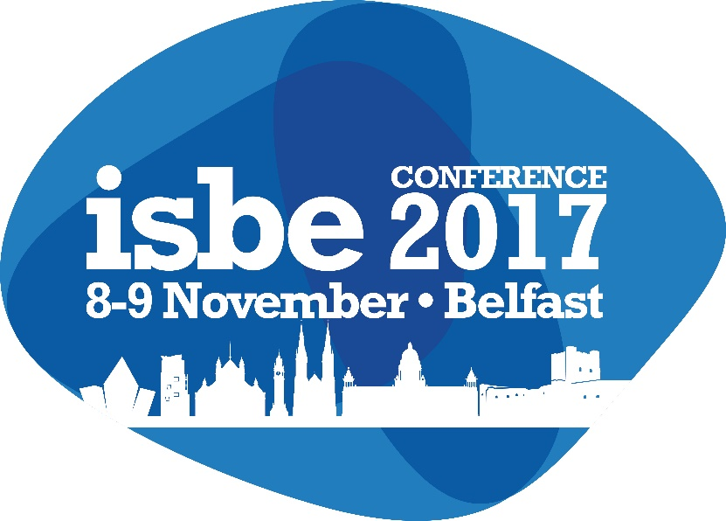

Author Guidelines
ISBE 2017

To ensure impartiality, please note that all abstracts and papers must be anonymized. Do not include contact details on your submission(s) but these should be included in the relevant fields as part of the submission process.

Submitting an abstract for review for the ISBE 2017 Conference
Abstracts can be submitted via the ISBE website during the submission window – Monday 6th March to Monday 10th April (11.59pm UK).
All abstracts are submitted to one of our conference tracks. You can find a list and full details of the tracks on the ISBE website.
Structure of your abstract
For ISBE 2017, we require an abstract of 750 words minimum (excluding any references).
Ensure that your abstract includes the following information:
- Topic
- Aim
- Methodology
- Contribution
A full reference list is not expected at abstract stage.
ISBE accepts six different types of submission:
- Full Papers
- Working Papers
- Practitioner Papers
- Case Studies
- PowerPoint Presentation
- Poster Sessions

Further information about our expectations for each submission type can be found in Appendix I of this document.

Decisions and feedback on all submitted abstracts will be sent to Corresponding Authors on Sunday 30th April.

Please note that only full research papers are eligible to be nominated for Best Paper Awards.

If you require any further information, or need any assistance, please don’t hesitate to contact us at authors@isbe.org.uk
Submitting a paper for review for the ISBE 2017 Conference
If your abstract is accepted for the conference, you are invited to submit your paper for expert review. Authors who have submitted abstracts for PowerPoint Presentations or Poster Sessions that have been accepted are not required to submit anything further.
A note on prior publication
All papers (except PowerPoint Presentations and Poster Session submissions) that are accepted for the ISBE Conference will be published in full on the Conference App and will be made available to ISBE members via the ISBE website after the event.
Authors should be aware that all ISBE papers are held within a members-only environment, and that papers are only accessible to ISBE members. All ISBE papers are attributed with a ISBN. Inclusion of a paper within the ISBE proceedings does not restrict further publication.

However, if authors have concerns that this may have a negative effect on their chances of future publication, and would prefer that only their abstract is included in the conference app, please email us at authors@isbe.org.uk so that this can be actioned.

Formatting and Layout
Papers should be formatted as follows:
- Paper Size: A4 (210mm x 297mm) with a 19mm margin all around
- Font: Arial, size 10, headings can be in bold but no underlining please
- Paragraph Format: Papers should be fully justified with single line spacing
- Title Page: To contain the following information:
  - Paper Title: No more than 85 characters including spaces – centred, 10pt Arial, bold and in title case i.e. capitals for first letter of main words. All papers should have a clear, concise title; the contribution of a paper should be evident from the title. The title should be no longer than 10 words. Titles which do not match the paper can cause frustration for reviewers.
  - Keywords: Up to six key words for indexing, cataloguing and classification – centred 10-pt
  - Do not include any author information
- Abstract: Using the headings given in your original abstract – justified, 10-pt Arial
- Main Text: Maximum 7,000 words, excluding tables, figures & references – single spaced, fully justified, 10pt Arial
- Pages: Title and abstract page, full text, tables, figures, references etc., all to fit on 20 pages maximum
- Subtitles: Left aligned in Arial bold
- Page Numbering: Right aligned in footer, in Arial 9pt font
- Citation and Referencing: Harvard Style (Jones, 2003), in 10pt Arial font. References should be listed in full at the end of the paper in alphabetical order
Reviewing Process
As you can appreciate, only limited feedback is given on abstracts; more detailed commentary will be available to authors once full papers have been submitted and reviewed by the Track Teams. Where the Track Chair feels a paper needs to be updated or amended in some way, this will be detailed in the review; you will then have an opportunity to address the issues raised and to revise the paper in time for Conference in November. The aim throughout the process is to work with the authors in a supportive and constructive way to improve the quality of the papers. Any suggestions to improve a paper are made in this context.
IMPORTANT NOTICE regarding ‘Final version’ papers
Authors only need to submit an abstract and, depending on the type of paper, the paper itself before Conference. There is no requirement for authors to submit a ‘final version’ paper once they have received feedback on their initial papers. This is on the expectation that authors revise their papers following the initial review and prior to the conference, and that feedback at the conference should be incorporated into 'final version' papers. If authors would like to submit a ‘final version’ paper for inclusion in the conference app, these can be sent to authors@isbe.org.uk after the conference. Note that any subsequent versions of papers that are submitted before the conference, and following reviewer feedback of initial papers, will not receive a second review.
All papers accepted for presentation at the conference and submitted by the required deadline will be included in the Conference App, however, this is subject to at least one author having registered for the conference and paid the appropriate fees by 30th September 2017. If you have not registered by this date, your paper will be withdrawn. Please note that, to facilitate track scheduling, no more than TWO papers can be accepted from any one lead author, or be presented by any one co-author.

2017 timetable
Date | Action
6th March 2017 | Abstract submission window opens
10th April 2017 | Extended deadline for submitting all abstracts
8th May 2017 | Notification to authors
15th May 2017 | Paper submission window opens
30th July 2017 | Early-booking discount for registration ends
11th August 2017 | Extended deadline for submitting papers
8th & 9th November 2017 | ISBE 2017 Conference, Europa hotel, Belfast

2017 turnaround times
Abstracts and papers are assigned to reviewers within one week of submission.
Reviews are returned to Track Chairs within one month of receipt by reviewers.
Reviews are approved by Track Chairs and made available to authors within a further two weeks.

Presentations at Conference
The oral presentation at the Conference should be delivered in English and focus on the following key features of the paper:
- Objectives / Key research question(s) of the paper
- Key model or framework used
- Nature and source of data used, including any key limitations to the methodology/methods
- Presentation of key findings – avoiding detailed discussion of statistical data
- Conclusions and implications for research, policy or practice
- Recommendations for future research and development
It is not necessary to include all the above features, only select those appropriate to your paper and the audience. Remember that the audience will typically comprise a mix of researchers, policy makers, enterprise support representatives and practitioners. The purpose of the presentation is to stimulate discussion and debate.
The preferred presentation format is Microsoft PowerPoint with a maximum of 6 slides, which must not exceed 15 minutes’ presentation time. Following feedback from delegates at ISBE 2016, Session Chairs will enforce strict timings.
Please bring your PowerPoint presentation to the conference on a USB memory stick and upload it onto the PC/laptop in the relevant presentation room before your presentation session is due to begin. You might like to bring a few photocopies of either your PowerPoint visuals or your full paper for handing out to interested delegates.

Queries/Problems
All queries or problems should be directed to our conference support team (authors@isbe.org.uk).

Appendix I: Expectations for Papers
Full Papers – these are papers which have been through a refereeing process by our expert reviewers and have been accepted – all refereed papers should be of publishable quality, potentially suitable for international journal publication. Full papers can be theoretical, conceptual, methodological and have an empirical dimension. All full papers are eligible for best paper awards.
In a full paper, the literature review is an important element and it is necessary to clearly articulate how the paper contributes to extant literature. Thus results, implications and value will be linked to the literature presented. The methodological orientation of full and working papers must be clearly articulated.
It is not necessary (unless the paper is a methodological one) to provide a long explanation of methodology. One should merely position the methodology within clear bounds. Only where justification is required will a lengthy methodology section be required.
All full papers submitted will be expected to make a contribution to their particular field.
As ISBE is keen to highlight policy and practical implications, where appropriate these are expected.

Working Papers – these are ongoing research pieces and give an insight into current research thinking and activities. They are an opportunity for authors to present their work and receive some constructive feedback prior to developing the research for publication. This classification can include PhD studies, pilot studies and initial stages of projects.

Working papers will contain many of the elements of a full paper but the review will be less rigorous. Such papers are intended for research in progress and will allow the author freedom to present research which may not yet be ready for publication as a full article.
The methodological orientation of full and working papers must be clearly articulated.
Less attention could be given to methodological considerations unless the methodology is unusual. A working paper can allow researchers to present unusual (avant-garde) work which they wish to present to peers, stimulate debate and receive feedback.
A working paper should be short and concise and a good comparison is that of a research note style. It should identify key issues for discussion and debate.

Practitioner Papers – these papers enable practitioners to highlight excellent and distinctive practice in enterprise creation and development. There must be evidence of the effectiveness of the practices presented with clear practical or policy implications highlighted.

Practitioner papers will vary depending upon the style, purpose and academic ability of the author. For example, they may or may not contain a literature review or methodology. Such papers will be judged by their contribution and logic. A good comparison would be that they may read like a short book chapter.

The abstract headings must be embedded in the structure of the article. Collaborations are especially encouraged between practitioners and academics. In practitioner papers, an explanation of methodology is desirable but not essential as long as authors clearly state what they did, why they did it and why it is important.

A well-written practitioner paper should be short (3,000-5,000 words) and to the point. The conclusion should have a moral which clearly sums up the logic and arguments in the paper. Book chapter or essay styles are welcome. Such papers should demonstrate a clear contribution to: relevant policy development; good practice; or a critical evaluation of current practice.

Case Studies – two types are welcomed. Case Studies may be submitted as examples of practice or as full teaching cases with teaching notes.

For the former, we welcome intensive studies of a single group, incident, or community; they should involve an in-depth, possibly even longitudinal examination of a single instance or event. We expect that from the case study a sharpened understanding of why the instance happened as it did, and what aspect might become important to look at more extensively in future research should be evident. For the latter, Harvard style, Case Centre or other appropriate format may be used. The inclusion of an abstract is not mandatory in respect of teaching cases.

Both types of case studies must be written with the abstract headings embedded in the structure. Obviously a teaching case study will differ from an empirical case study but in both the objectives, approaches, results, implications and value must be clearly articulated.
As teaching case studies are a methodology in their own right, there is no need to dwell on methodology unless the case is built around an unusual data capture methodology.
Cases studies should be short and concise and articles which deviate too much from the purpose of a case study are discouraged.
Teaching cases should be submitted along with a short accompanying summary. However, contributors must structure their presentation around the abstract themes. Pedagogical contributions from the case should be explored.

PowerPoint Presentation – for work in its very earliest stage, there are a limited number of spaces for PowerPoint presentations at the conference with no accompanying written paper. A full review is not given for this type of submission, and only the abstract will be included in the proceedings on the conference app.

A PowerPoint presentation must have an abstract and outline details of the presentation.
PowerPoint presentations should be accompanied by a short written overview which elaborates upon the aims and objectives of the project, current stage of development and key issues the author intends to raise for discussion.
Presentations will still be limited to 6-8 slides. The methodological orientation must be clearly articulated.

Poster Sessions - we would expect that these sessions will be a useful opportunity for postgraduate and early career researchers to obtain expert feedback about their work. Applicants are asked to submit a short abstract giving brief information and background to their work. A full review is not given for this type of submission, and there is no requirement to submit anything further than the short abstract. Poster Session abstracts are not included in the proceedings on the conference app.
Posters should be a one-page poster that can be attached to the wall of a conference breakout room. Depending on the track schedule, it may be possible to talk through your poster but please note this is not guaranteed.
Authors are responsible for the transit of their poster to and from the conference venue.

