Carbon Trust/Kingston University Energy Efficiency Training for SMEs

This event – held at Kingston University in London on 27 April 2017 – aimed to show how small/ new businesses can reduce energy consumption, lower costs and improve their reputation.

Delegates received free energy efficiency training from a Carbon Trust expert and advice on initiatives on offer that provide funded support and resources. One such programme is START2ACT, which funded the event, and which offered delegates the opportunity to sign up to receive one-to-one bespoke START2ACT energy efficiency-related support.

Delegates were briefed on related activities being undertaken by the Institute for Small Business and Entrepreneurship special interest group for social and sustainable enterprise, of which event co-organiser Professor Audley Genus of Kingston Business School, is co-chair. There was a briefing on support on offer from Kingston University’s Sustainability Hub and the €3.2 million ‘ENERGISE’ EU Horizon 2020 project on innovation and good practice for sustainable consumption, on which Professor Genus is a work package leader,

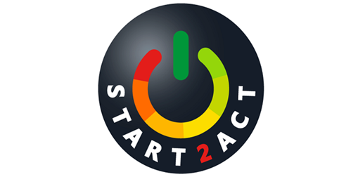

This event has received funding from the European Union’s Horizon 2020 research and innovation programme under grant agreement No 696069 and support from Kingston University and ISBE’s Social and Sustainable Enterprise special interest group.

